ERD

with tot_prod as(

select

cust.name

, count(tr_m_prod.customer) total_transaksi

, sum(coalesce(to_number(substring(tr_m_prod.harga_asli, 3, position('.' in tr_m_prod.harga_asli)-3),'L9G999g999g999.99'), 0))

::float8::numeric::money jumlah_product

from schoters.customer cust

join schoters.transaksi_main_produk tr_m_prod

on cust.name = tr_m_prod.customer

group by cust.name

order by jumlah_product desc

)

, tot_serv as(

select

cust.name

, count(tr_serv.customer) total_transaksi

, sum(coalesce(to_number(substring(tr_serv.harga_service, 3, position('.' in tr_serv.harga_service)-3),'L9G999g999g999.99'), 0))

::float8::numeric::money jumlah_service

from schoters.customer cust

join schoters.transaksi_service tr_serv

on cust.name = tr_serv.customer

group by cust.name

order by jumlah_service desc

)

select

coalesce (tp.name, ts.name) as name

, (tp.total_transaksi + ts.total_transaksi) as total_transaksi_produk_dan_service

, (tp.jumlah_product + ts.jumlah_service) as jumlah_transaksi_produk_dan_service

from tot_prod tp

join tot_serv ts

on tp.name = ts.name

order by jumlah_transaksi_produk_dan_service desc

fetch first 5 rows only

;



with tot_prod as(

select

cust.domisili

, count(tr_m_prod.customer) total_transaksi

, sum(coalesce(to_number(substring(tr_m_prod.harga_asli, 3, position('.' in tr_m_prod.harga_asli)-3),'L9G999g999g999.99'), 0))

::float8::numeric::money jumlah_product

from schoters.customer cust

join schoters.transaksi_main_produk tr_m_prod

on cust.name = tr_m_prod.customer

group by cust.domisili

order by jumlah_product desc

)

, tot_serv as(

select

cust.domisili

, count(tr_serv.customer) total_transaksi

, sum(coalesce(to_number(substring(tr_serv.harga_service, 3, position('.' in tr_serv.harga_service)-3),'L9G999g999g999.99'), 0))

::float8::numeric::money jumlah_service

from schoters.customer cust

join schoters.transaksi_service tr_serv

on cust.name = tr_serv.customer

group by cust.domisili

order by jumlah_service desc

)

select

coalesce (tp.domisili, ts.domisili) as domisili

, (tp.total_transaksi + ts.total_transaksi) as total_transaksi_produk_dan_service

, (tp.jumlah_product + ts.jumlah_service) as jumlah_transaksi_produk_dan_service

from tot_prod tp

join tot_serv ts

on tp.domisili = ts.domisili

order by jumlah_transaksi_produk_dan_service desc

fetch first 5 rows only

;



with tot_prod as(

select

to_char(tr_m_prod.tanggal_transaksi, 'Month') as bulan

, to_char(tr_m_prod.tanggal_transaksi, 'mm-yyyy') as tgl_bulan

, count(tr_m_prod.customer) total_transaksi

, sum(coalesce(to_number(substring(tr_m_prod.harga_asli, 3, position('.' in tr_m_prod.harga_asli)-3),'L9G999g999g999.99'), 0))

::float8::numeric::money jumlah_product

from schoters.customer cust

join schoters.transaksi_main_produk tr_m_prod

on cust.name = tr_m_prod.customer

group by bulan, tgl_bulan

order by tgl_bulan

)

, tot_serv as(

select

to_char(tr_serv.tanggal_service, 'Month') as bulan

, to_char(tr_serv.tanggal_service, 'mm-yyyy') as tgl_bulan

, count(tr_serv.customer) total_transaksi

, sum(coalesce(to_number(substring(tr_serv.harga_service, 3, position('.' in tr_serv.harga_service)-3),'L9G999g999g999.99'), 0))

::float8::numeric::money jumlah_service

from schoters.customer cust

join schoters.transaksi_service tr_serv

on cust.name = tr_serv.customer

group by bulan, tgl_bulan

order by tgl_bulan

)

select

coalesce (tp.bulan, ts.bulan) as bulan

, coalesce (tp.tgl_bulan, ts.tgl_bulan) as tgl_bulan

, coalesce((tp.total_transaksi + ts.total_transaksi),tp.total_transaksi,ts.total_transaksi) as total_transaksi_produk_dan_service

, coalesce((tp.jumlah_product + ts.jumlah_service),tp.jumlah_product,ts.jumlah_service) as jumlah_transaksi_produk_dan_service

from tot_prod tp

full join tot_serv ts

on tp.bulan = ts.bulan and tp.tgl_bulan = ts.tgl_bulan

order by tgl_bulan

;



select

count(tr_m_prod.customer) total_wanita

, tr_m_prod.tipe_produk

from schoters.customer cust

join schoters.transaksi_main_produk tr_m_prod

on cust.name = tr_m_prod.customer

where lower(cust.gender) = 'wanita'

and cust.usia between 20 and 29

group by tr_m_prod.tipe_produk

order by total_wanita desc

-- fetch first 3 rows only

;

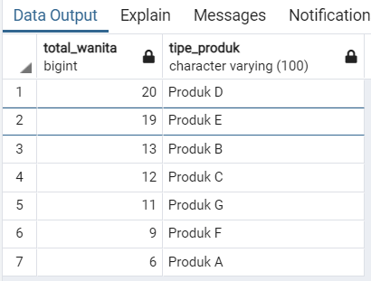



with tot_prod as(

select

cust.name

, rev_p.rating

, count(tr_m_prod.customer) total_transaksi

, sum(coalesce(to_number(substring(tr_m_prod.harga_asli, 3, position('.' in tr_m_prod.harga_asli)-3),'L9G999g999g999.99'), 0))

::float8::numeric::money jumlah_product

from schoters.customer cust

join schoters.transaksi_main_produk tr_m_prod

on cust.name = tr_m_prod.customer

join schoters.review_perusahaan rev_p

on cust.name = rev_p.name

where rev_p.rating < 5

group by cust.name, rev_p.rating

order by rev_p.rating

)

, tot_serv as(

select

cust.name

, rev_p.rating

, count(tr_serv.customer) total_transaksi

, sum(coalesce(to_number(substring(tr_serv.harga_service, 3, position('.' in tr_serv.harga_service)-3),'L9G999g999g999.99'), 0))

::float8::numeric::money jumlah_service

from schoters.customer cust

join schoters.transaksi_service tr_serv

on cust.name = tr_serv.customer

join schoters.review_perusahaan rev_p

on cust.name = rev_p.name

where rev_p.rating < 5

group by cust.name, rev_p.rating

order by rev_p.rating

)

select

coalesce (tp.name, ts.name) as name

,coalesce (tp.rating, ts.rating) as rating

, coalesce((tp.total_transaksi + ts.total_transaksi),tp.total_transaksi,ts.total_transaksi) as total_transaksi_produk_dan_service

, coalesce((tp.jumlah_product + ts.jumlah_service),tp.jumlah_product,ts.jumlah_service) as jumlah_transaksi_produk_dan_service

from tot_prod tp

full join tot_serv ts

on tp.name = ts.name

order by rating

;



with tot_prod as(

select

tr_m_prod.tanggal_transaksi

, count(tr_m_prod.customer) total_transaksi

, sum(coalesce(to_number(substring(tr_m_prod.harga_asli, 3, position('.' in tr_m_prod.harga_asli)-3),'L9G999g999g999.99'), 0))

::float8::numeric::money jumlah_product

from schoters.customer cust

join schoters.transaksi_main_produk tr_m_prod

on cust.name = tr_m_prod.customer

group by tr_m_prod.tanggal_transaksi

order by tr_m_prod.tanggal_transaksi

)

, tot_serv as(

select

tr_serv.tanggal_service

, count(tr_serv.customer) total_transaksi

, sum(coalesce(to_number(substring(tr_serv.harga_service, 3, position('.' in tr_serv.harga_service)-3),'L9G999g999g999.99'), 0))

::float8::numeric::money jumlah_service

from schoters.customer cust

join schoters.transaksi_service tr_serv

on cust.name = tr_serv.customer

group by tr_serv.tanggal_service

order by tr_serv.tanggal_service

)

select

mc.name

, sum(semua.total_transaksi_produk_dan_service)

, sum(semua.jumlah_transaksi_produk_dan_service)

from (

select

coalesce (tp.tanggal_transaksi, ts.tanggal_service) as tanggal

, coalesce((tp.total_transaksi + ts.total_transaksi),tp.total_transaksi,ts.total_transaksi) total_transaksi_produk_dan_service

, coalesce((tp.jumlah_product + ts.jumlah_service),tp.jumlah_product,ts.jumlah_service) as jumlah_transaksi_produk_dan_service

from tot_prod tp

full join tot_serv ts

on tp.tanggal_transaksi = ts.tanggal_service

order by tanggal

) semua

join schoters.marketing_campaign mc

on semua.tanggal between mc.start_date and mc.end_date

group by mc.name

order by mc.name

;

Eksplorasi Data Analysis (EDA)

**Chart1**

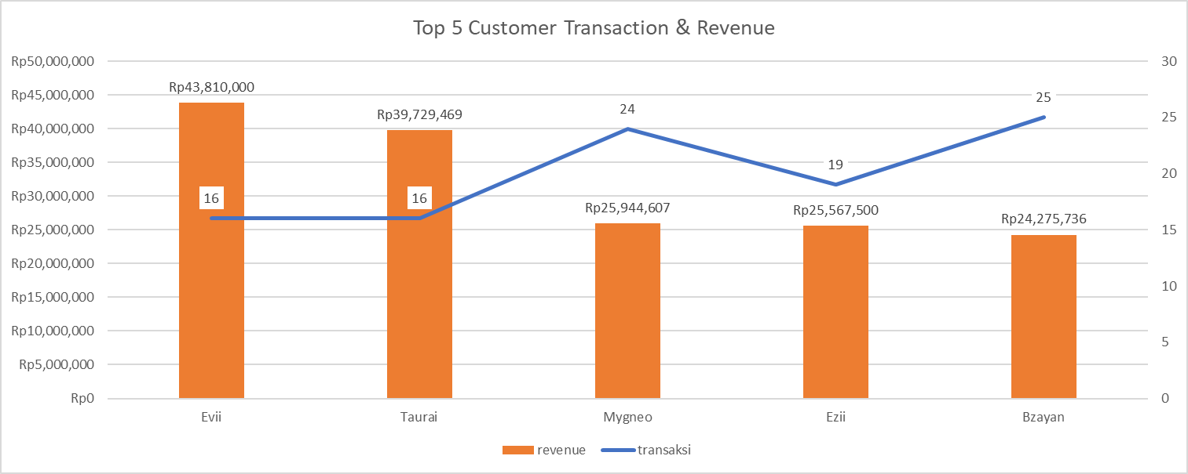

Pada top 5 Customer, Evii mendatangkan revenue paling tinggi walaupun jumlah transaksinya tidak sebanyak Bzayan. Selisih revenue Top 1 dan Top 2 sangat tinggi sedangkan untuk top 3-5 selisih revenuenya tidak besar (sekitar 25 juta-an)

**Chart2**

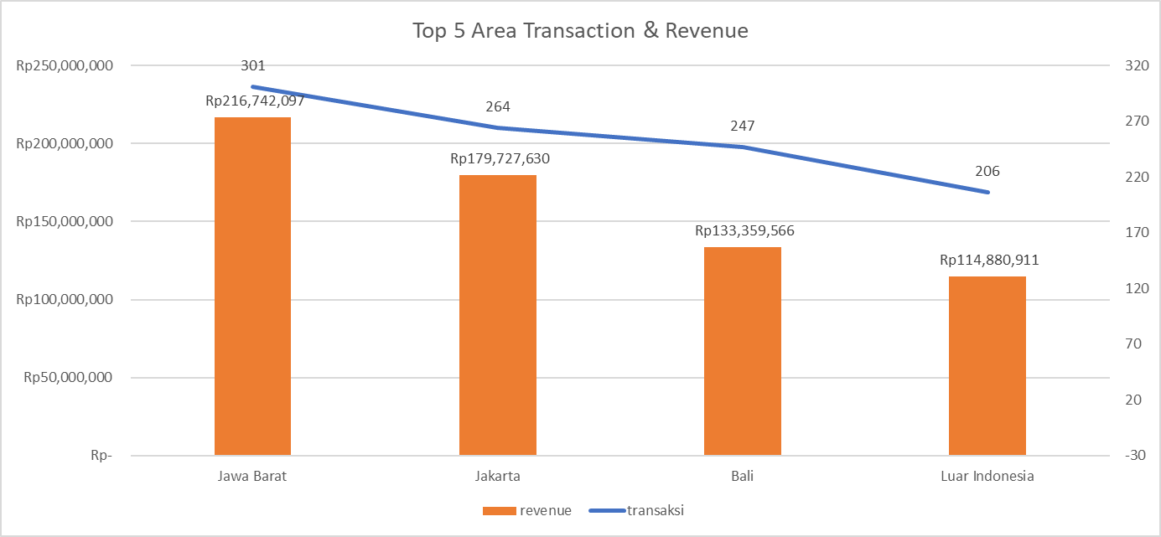

Area Jawa barat mendatangkan banyak revenue dan transaksi. Revenue dan transaksi berbanding lurus untuk kategori area. Memiliki korelasi yang tinggi R2 = 0.9182

**Chart3**

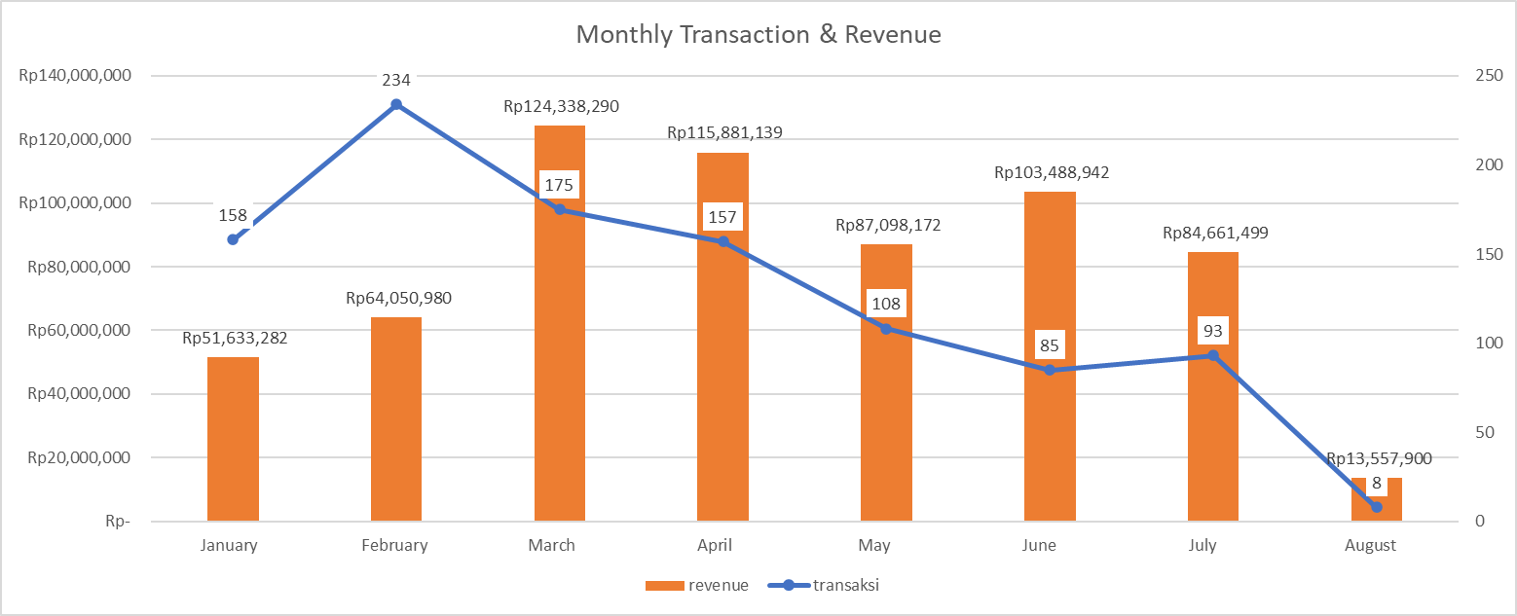

Revenue 80 juta – 130 juta dapat terlihat pada bulan Maret – Juli. Sementara total transaksi melambung tinggi pada bulan Februari walau revenuenya tidak besar-besar amat. Bulan Agustus terjadi revenue dan transaksi paling rendah.

**Chart4**

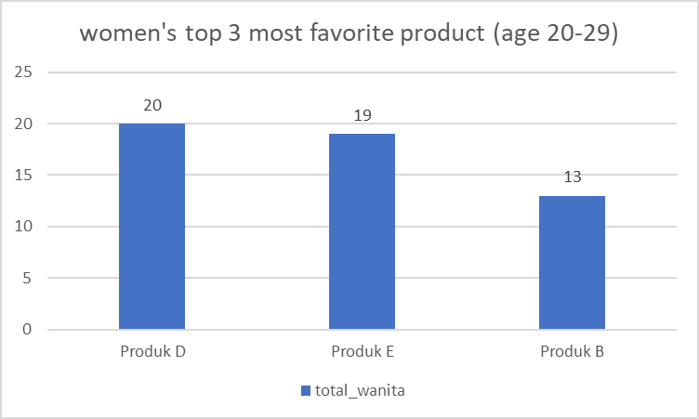

Dapat disimpulkan bahwa produk D,E,B merupakan produk terbanyak yang dibeli.

**Chart5**

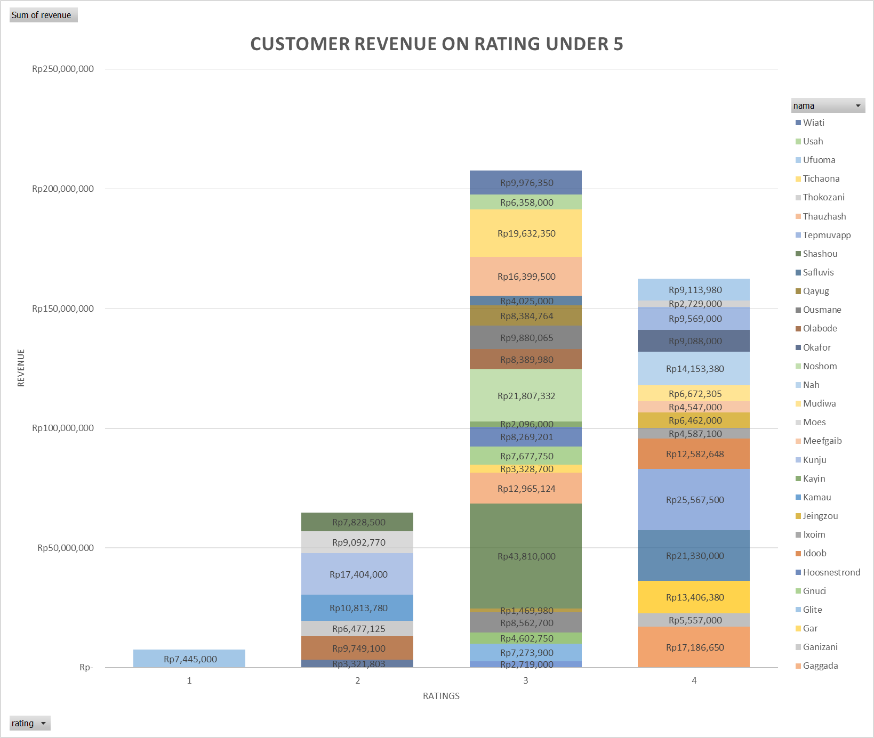

Banyak costumer memberi rating 3 & 4 dapat dilihat keseluruhan akumulasi revenue costumer tertinggi pada customer yang memberikan rating 3. Walau rating 3 dan 4 hanya berbeda 30-40 juta-an saja.

Hanya 1 customer yang memberikan rating 1. Revenue customer Rating 2 juga tidak boleh diremehkan karena melebihi 50 juta-an.

**Chart6**

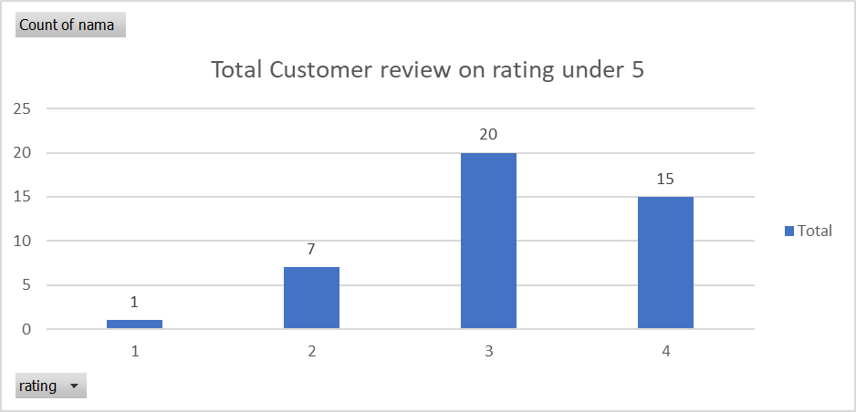

Pada grafik Total Customer review on rating under 5 terlihat bahwa banyak customer yang memberi review 3 & 4.

**Chart7**

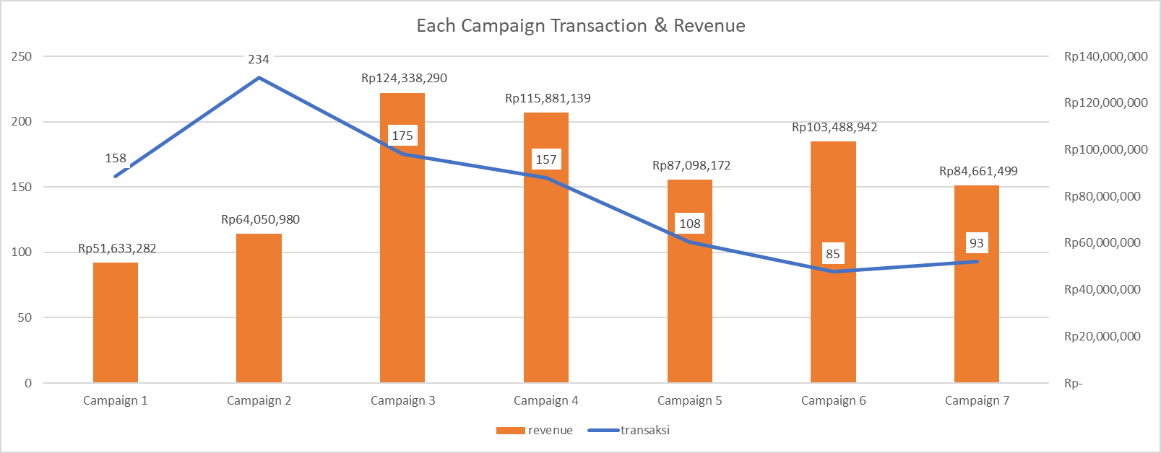

Pada campaign ini datanya hampir sama dengan chart **Monthly Transaction & Revenue (Chart3)** serta pembahasannya juga mirip2 dengan chart tersebut. Yang membedakan pada bulan Agustus tidak ada marketing campaign.

**SARAN Improvement :**

* **Marketing campaign sangatlah diperlukan inilah yang menyebabkan bulan Agustus mendapatkan revenue yang sedikit. Marketing campaign perlu diadakan setiap bulan.**
* **Rating juga sangat berpengaruh terhadap revenue. Banyak revenue customer pada rating 3 & 4, jika ditotal bisa mencapai 350 juta keatas. Perlu diperhatikan & jangan diremehkan perlakuan customer pada rating tersebut.**
* **Untuk daerah focus terlebih dahulu pada Jakarta & Jawa Barat karena mendatangkan banyak revenue. Akan tetapi, area Bali & luar Indonesia juga perlu dipertahankan agar target tidak turun dari tahun sebelumnya.**